St. George’s CEP Newsletter Issue 23: Friday 7th March 2025

October 2022

2020



***‘Bringing faith and education together’***

‘Letting our light shine’ (Matthew 5:16)

Sports Day 2017

A reminder that EYFS Sports Day is on 5th July and KS1 and 2 Sports Day is on 6th July.

Please note that Hyde Park class will participate in Sports Day in the morning, starting at 9:15 and St. James’ Park in the afternoon, starting at 1:45.

**You can find out about what’s going on at St George’s in a variety of ways:**

**Visit the school website:** [**www.st-georges-wrotham.kent.sch.uk/**](http://www.st-georges-wrotham.kent.sch.uk/)

**Follow us on twitter: @StGeorgesKent and Instagram: stgeorgesceprimary_wrotham**

**Keep up to date with newsletters on our website and keep an eye on the class pages**

***Respect Courage Kindness Forgiveness Hope Honesty***

**Parent Consultations**

Booking has gone live – make sure you book your slot as it is a great mid-year indicator of how your child is working towards their end of year goals.

Thursday 13th March: Oak (Yr R) Class Consultations

Tuesday 18th March: Oak (Yr R) Class and Year 1 to Year 6 consultations

Thursday 20th March: Year 1 to Year 6 consultations

Reminder that Cedar Class (Year 3) consultations have been postponed until Miss Huggett’s return

It feels like Spring is here with the sunshine out this week – hitting the dizzy heights of 16 degrees on Thursday gives us a feel for summer being on the horizon! The sun makes everything seem a little brighter, but I am aware that means there is an influx of children and parents going to the park after school. Please make sure that you are supervising your children during these times and be aware that cars will be travelling up and down London Road for longer. We have had a few near misses with road crossings– please think about others safety.

Mr Godoy is back this term – lucky for us, this time for 2 mornings, as he’s really enjoyed his time teaching PE with Year 1 (Beech) and Year 5 (Hazel), which means Year 3 (Cedar) and Year 4 (Willow), will also have him too! Adrian Crust, from Chance To Shine, will be back later in the term to do some cricket coaching with some of our younger classes. I’m very proud that people that come to our school want to keep coming back – absolute testament to the children as their enthusiasm, resilience and behaviour!

We also had a Maths specialist and some students from Sevenoaks school, delivering the first of their Magical Maths sessions, with some children in Year 6 – they also spoke about how engaged the children were.

Well done to Year 4 (Willow Class) leading our Family Service at St George’s Church at the start of the week, followed by the excitement of Pancake Races across the school on Tuesday. There were some close races in the heats but ended up with Max being our Key Stage 1 Champion and Nate being this year’s 2025 Pancake Champion!

I think the biggest excitement this week has been World Book Day! There are always so many fabulous costumes and some fun activities to enjoy across the school. Enjoy the photos!

On a sadder note, many of you will have seen Miss Huggett (Year 3 teacher) sporting a very bad knee injury. She hoped it would get better in time but sadly has been told that it is a serious condition and needs to have it operated on. Following this she also needs to recuperate so we all wish her a speedy recovery and hope to see her back in school before the end of term.

**Do not let kindness and truth leave you. [Proverbs 3:3]**

**Attendance** is important and our aim is to achieve **above** 96%.

Whole school attendance this **year** so far is **95.2%**

Attendance this week:

Oak (Year R): 96.8%

Beech (Year 1): 98.3%

Maple (Year 2): 97.0%

Cedar (Year 3): 96.3%

Willow (Year 4): 95.0%

Hazel (Year 5): 92.4%

Sycamore (Year 6): 95.0%

**Congratulations to:**

**BEECH CLASS**

**You are the highest attenders**

**this week!**

For unexpected absence eg illness for example, please call and speak to the school office before 9.30am so absence can be recorded accurately.

If they have an appointment during the school day you MUST provide evidence of an appointment.

Any other absence must be requested using our absence request form. This can be found through this link:

<https://forms.gle/3dVUrxXZt9v5REKR9>

**Times Tables Rockstars** this week:

Maple (Year 2): Henry & Lola

Cedar (Year 3): Johnny & Maggie

Willow (Year 4): Finley & Roxana

Hazel (Year 5): Kaiden & Samantha

Sycamore (Year 6): Isabel

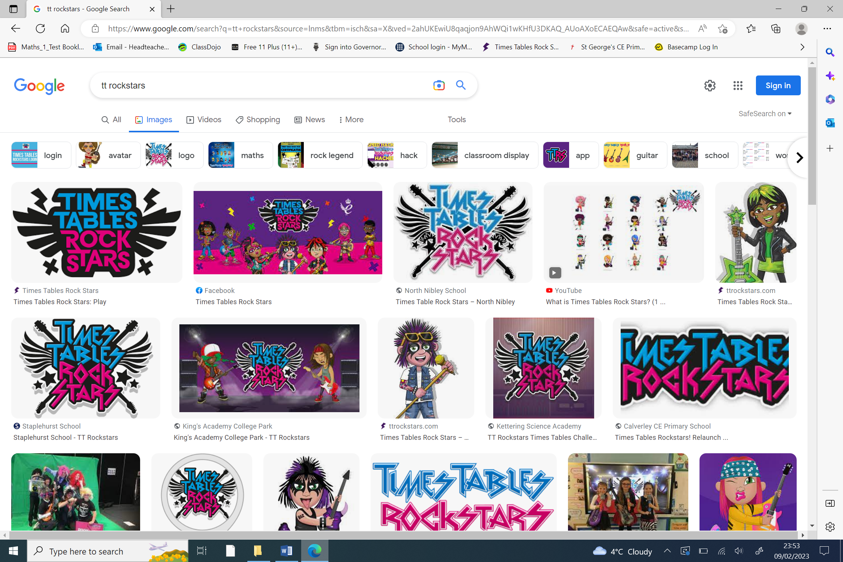

Dojo Points Winning House for this week:

**St. David’s**

**‘Letting Your Light Shine’**

**(Matthew 5:16)**

This corner on our newsletter highlights people connected to our school who fulfill our school vision, this week that honour goes to…

**Max and Nate!**

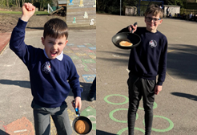

**Pancake Champions for 2025!**

**What’s Coming Up Next Week?**

Next week is **Science Week** in school. There will be some fun activities in classes across the school to be enjoyed.

Cedar Class (Year 3) and Sycamore Class (Year 6) are off on visits to develop their learning in RE and Science. Today Beech Class (Year 1) are visiting Kent Life so there will be some interesting news to share next week!

There will be sports news to share too so watch this space!

**Bringing faith and education together**



Bringing **faith** and **education** together

**“Letting our light shine” (Matthew 5:16)**

**Our week in pictures…**



